Categories Count:
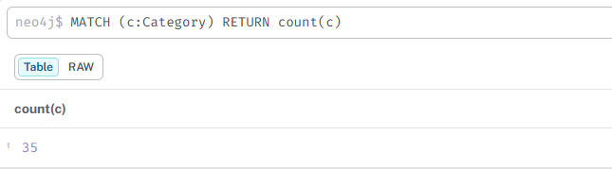

ONDC Mapping:
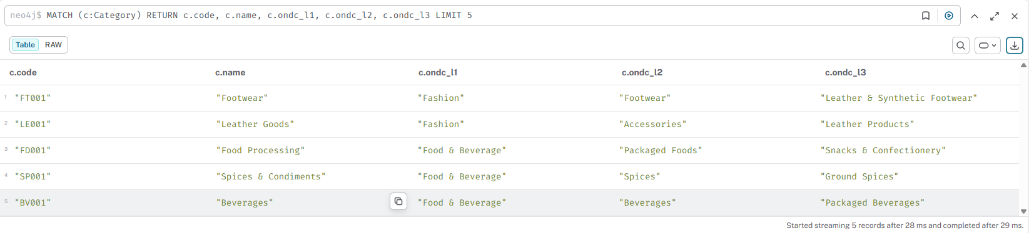
Hindi Keywords:
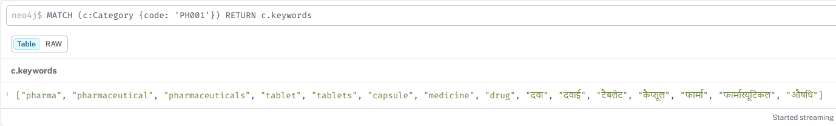
SNP Metadata:
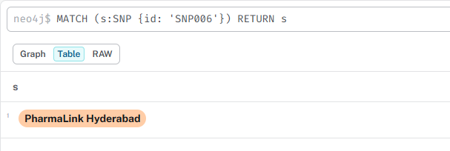

Graph Visualization:
